Pearl Ayem – 34404160

**ATSC 303 Lab 9 Radiation**

Lab Questions:

1. Plot Radiation

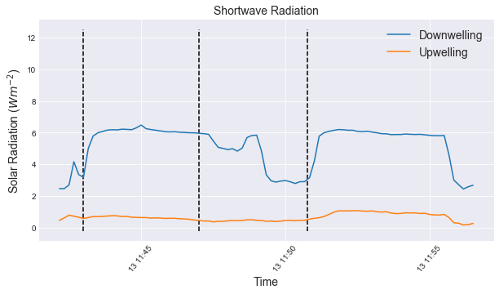



1. The albedo was calculated using the following formula: $$α= \frac{K↑}{K↓}$$

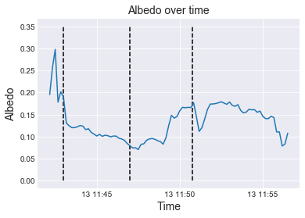



Bare desk average albedo = 0.11

White paper average albedo = 0.16

1. Part 2 Data Analysis:
   1. Ground Temperature

The formula used to estimate the ground temperature was a rearrangement of the Stefan-Boltzman Law.

$T= \sqrt[4]{\frac{E}{σ}}-273.15$ to convert temperature in ℃.

Where

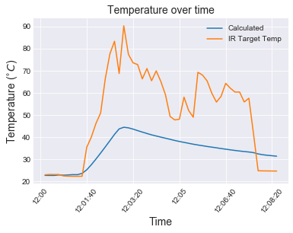

* 1. The calculated temperature is lower than what was measured by the IR thermometer. This could be due to the self heating in the sensor itself, as well as properties of the material itself as well as the sensor’s proximity to the hot plate. Additionally, the IRT does not measure local air temperature, but a weighted average temperature from the atmospheric sources of radiation which are emitting in its wavelength window. The calculation relied on the upwelling longwave radiation to find temperature which created a discrepancy.

1. Since the body of the pyrgeometer also emits longwave radiation, this must be accounted for by subtracting the pyrgeometer’s emitted longwave radiation by measuring the body temperature of the instrument which is measured by the PRT. Without these the reading collected by the longwave sensors will be higher than the actual radiation.

Further Questions

1. Plots for each field day in Whistler:

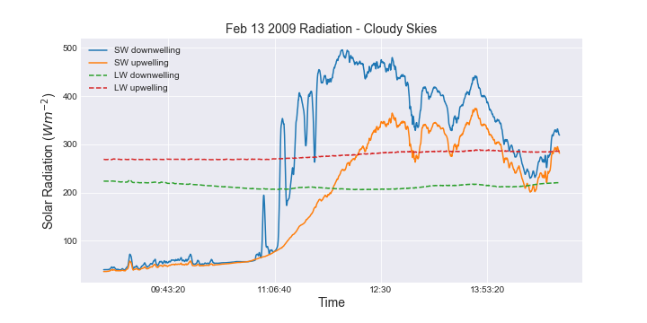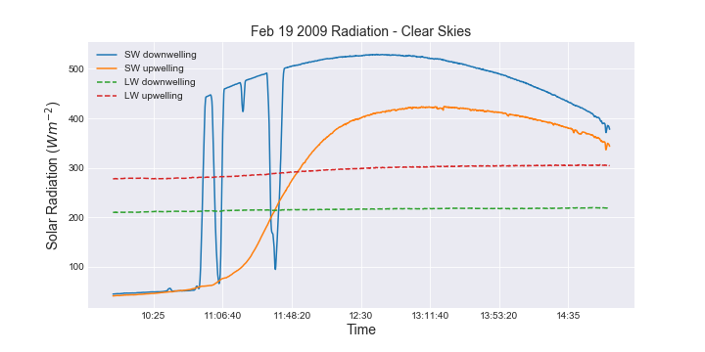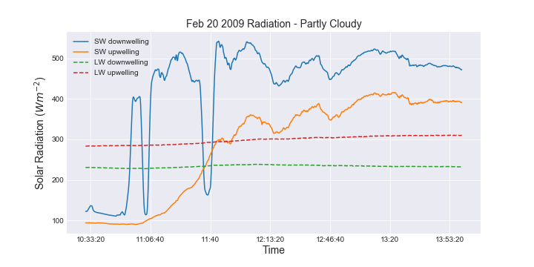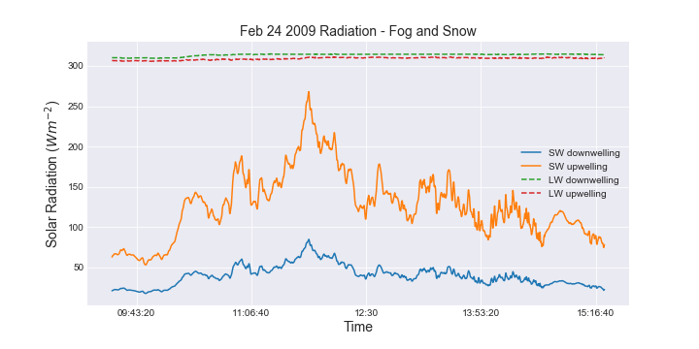

1. Match dates to the following sky and weather conditions
   1. Mostly cloudy skies, especially in the morning. No precipitation 🡪 Feb 13, 2009
   2. Partly cloudy skies. No precipitation 🡪 Feb 20, 2009
   3. Clear skies. No precipitation 🡪 Feb 19, 2009
   4. Fog and snow 🡪 Feb 24, 2009
2. Sensor surrounding questions:
   1. On the day with clear skies, the radiation sensors itself may have had frost or dew on them in the morning that could have skewed the reading. The morning sun is also at a lower angle due to which there is more diffused radiation which could affect the reading. If the sensor had shadows casted onto it due to nearby trees or mountains there could be dips in the reading. Once the temperatures are warm enough for the accumulated frost or dew to melt/evaporate or sunlight to be directly overhead and not cast shadows, the curve was smoother.
   2. I don’t think it was ideal because the sensor was suspended (as per the pictures shown in lecture), had shadows casted due to trees and mountains, and radiometers were covered by snow.
3. Clouds absorb some amount of incoming radiation and radiate it towards the surface of the Earth in the longwave. The also absorb any outgoing radiation and radiate it back to the ground. These add to the incoming longwave budget of the planet. On a clear day, the downwelling longwave was much lower because the portion of radiation emitted by clouds was absent.
4. Dust, air molecules and cloud droplets in the atmosphere scatter the incoming solar radiation which the pyranometer detects as diffuses solar radiation which could potentially increase the irradiance detected at the surface. On a cloudless day the presence of dust and PM could still increased diffused radiation.
5. Define the following:
   1. Pyranometer: Measure short-wave radiation from the solid angle 2π incident on a plane surface (K↓ or K↑).
   2. Pyrheliometer: Measures direct-beam short-wave at normal incidence.
   3. Pyrradiometer: Measure total radiation from the solid angle 2π incident on a plane surface (Q↓ or Q↑).
   4. Net Pyrradiometer: Measures net all-wave radiation from above and below (Q*).
6. The double glass domes have radiative properties such that they only allow radiation in the band from 0.3 to 3.0µm to pass through to the receiving surface. This acts as a spectral ﬁlter to distinguish short wave (which it wants to detect) from the long wave radiation ﬂuxes. Additionally, it is a means of standardizing convective heat exchange at the thermopile surface to reduce the effects of wind speed to the energy balance of the instrument.
7. Combining the two sensors creates a sensor to measure only measures only diffused shortwave radiation.
8. It creates a net radiometer that measures all incoming longwave and short-wave radiation from the ground and the atmosphere